**A Greedy-based calculation method of RBS maximum allowable current**

Cheng Qian, Guangbin Hua, Binghui Xu, Quan Xia, Bo Sun, Yi Ren, Zili Wang

School of Reliability and Systems Engineering, Beihang University, Beijing, 100191, China

**Abstract**

Reconfigurable Battery Systems (RBSs) offer a promising alternative to traditional battery systems owing to their dynamical topologic structure for the optimization of battery cell charging and discharging strategies. During the operation of the RBS, the Maximum Allowable Current (MAC) is a critical indicator to guide the refactoring control of the system in terms of safety and reliability. This paper firstly proposes a method to calculate the MAC of the RBS based on its structure. In the developed method, the directed graph is utilized to model the structure of RBS, and a greedy strategy is proposed to find the potential connections of batteries that enable the maximum current. Finally, an equivalent circuit model of battery cell is employed to calculate the current value of the selected circuit. The effectiveness of this method is validated on RBS structures of various sizes and configurations. The results also demonstrate that the ratio of the output current to the maximum battery current can better reflect the structural performance of RBS than the output current value.

**Keywords**

Reconfigurable battery system, maximum allowable current, greedy algorithm,

**I. Introduction**

Battery Energy Storage Systems (BESSs) are widely used to store and supply high-quality electrical energy in various applications, such as electric vehicles and wind power plants [1, 2, 3, 4]. Typically, a BESS consists of numerous battery cells that are interconnected by series-parallel circuitry to provide the required charged capacity and output voltage. For the traditional BESS, the connections between batteries are fixed and the performance of system is limited by the worst cell, as the result of the cask effect. Furthermore, reliability and even safety issues will also be aroused since the failed battery cannot be promptly isolated to exacerbate the degradation of the other batteries during the operational process [5, 6]. Undoubtedly these issues hinder the practical application of traditional BESSs.

Reconfigurable Battery System (RBS), which can dynamically switch to arbitrary circuit configurations as required, is expected to solve the above problems [9]. Unlike traditional BESSs with a fixed battery connection, RBS use additional switches to change the series/parallel connection mode between batteries, which greatly improves the flexibility, safety and reliability of the system. Fig.1 shows two popular typologies of the RBSs developed by Lawson [7] and Visairo [8] respectively. Taking the RBS shown in Fig.1 (b) as example, the batteries are connected not only in series when the switches $S_{1}$, $S_{5}$, $S_{6}$, $S_{7}$, $S_{8}$, $S_{9}$, and $S_{13}$ are closed, but also in parallel when $S_{1}$, $S_{2}$, $S_{3}$, $S_{4}$, $S_{5}$, $S_{9}$, $S_{10}$, $S_{11}$, $S_{12}$ and $S_{13}$ are closed. Furthermore, when an unhealthy battery, for instance the orange one in Fig.1 (a), exists in the RBS, it can be isolated by closing its three adjacent switches (i.e. S5, S7 and S8) and opening the switch below that battery (i.e. S6) to ensure the system still remains a reliable working mode.



**Fig. 1 The RBS structure proposed by (a): Lawson [7], (b): Visairo [8] and (c): synthesized from (a) and (b).**

The complex connection structure between batteries and switches enables the flexibility of the RBS, but also brings the challenges in design and control cost. The Maximum Allowable Current (MAC) of the RBS system is defined as the maximum current that is allowed for each individual battery of the system, and is a critical indictor to be evaluate the RBS output current to the electronic appliances. It helps the designers to assess whether the RBS meets the output current requirements, and contributes to the formulation of appropriate and safe management strategies for the battery management system (BMS). Despite its importance, there is currently no method available to evaluate MAC for RBSs. Therefore, the purpose of this paper is to propose a universal and effective method for calculating the MAC of the RBS. To achieve this, models with RBS connection relationships and component status information are established. Then, a greedy algorithm is employed to search the available circuit of the RBS for reaching the MAC. With the developed method, MAC of RBSs with different structures or different number of batteries can be calculated effectively.

The remainder of this paper is structured as follows: Section II presents the framework and details of the proposed XX model. In Section III, taking a specific structure as an example, the application of the method is demonstrated, and the effectiveness of the method on RBS with different structures and sizes is verified. Finally, the concluding remarks are drawn in Section IV.

**II. Methodology**

The overall MAC modelling process from an RBS structure is shown in Fig. 2, which can be divided into four main steps. In the first place, the actual RBS structure is converted to a graph model, in which the shortest path of … is obtained. Then, an equivalent circuit model is established based on the graph model for solving the voltage and current in the circuit. Finally, by greedily searching for the combination of the shortest path, the MAC is calculated in the corresponding equivalent circuit model.



**Fig. 2 Flowchart of the MAC modeling process.**

**A. Graph model and circuit model**

As demonstrated in Fig. 1, a typical RBS is made up of a number of battery cells and switches in a dynamically adjustable connection. To establish a processable circuit, these components are transformed into ideal elements under reasonable assumptions. The resulting circuit structure is then described in matrix form, and the related equations are provided.

The normal equivalent circuit for a battery consists of a voltage source in series with a resistor, and a capacitor in parallel with another resistor to simulate the polarization in batteries. When calculating the MAC that can be delivered steadily from the RBS, only the steady-state behavior of the battery is considered, where the transient behavior is ignored. In this way, battery $i$ in the RBS is modeled by the series connection in between a constant voltage source $u_{b,i}$ and a resistor $r_{b,i}$. And a binary variable $x_{j}$ is used to represent the state of switch $j$, which are 0 for ON and 1 for OFF, respectively. To simplify the calculation, a closed switch is considered as a resistor with a very small resistance value $r_{s}$.

For a given RBS architecture, a directed graph model $G(V,E)$ for the RBS is constructed in such a way that:

* Nodes: the vertex set $V=\{v_{1},v_{2},…,v_{n}\}$ represents the nodes connecting batteries and/or switches, where $v_{1}$ and $v_{n}$ represent the anode and cathode of the RBS respectively, and the …;
* Edges: the directed edge set $E$ represents the output circuit, $N_{b}$ batteries and $N_{s}$ switches, corresponding set $E_{O}$, $E_{b}$ and $E_{s}$. The external electrical equipment in the output circuit is treated as one directed edge $v_{n}→v_{1}$. The direction of the edge indicates that the battery is set to be from the anode to the cathode. For the edges representing switches, their directions are marked from the low node to the high node. A negative voltage drop or current indicates the direction of the corresponding edge should be opposite to its initially settings.



















**B. Greedy solution**

First, the shortest path ($SP_{i}$) of battery $i$ is calculated. When battery $i$ is connected to the anode $v_{1}$ and the cathode $v_{n}$ of the RBS by the path $p$ in the graph model, the length $ω$ of $p$ is defined by the following equation:

where $N_{s}$ is the total number of switches in the system; $n_{b}(p)$ and $n_{s}(p)$ are number of batteries and switches in the path $p$ respectively. $SP_{i}$ is defined as the path with the minimum $ω$ for battery $i$. According to the definition, $SP_{i}$ gives the simplest strategy by which the control of battery $i$ is achieved with a minimum of switches while minimizing the influence of other batteries. From the perspective of series/parallel, the more batteries are connected into circuit via their SPs, the more batteries are connected in parallel. Since batteries can provide more total output current when connected in parallel than in series, the algorithm greedily selects as many cells as possible to be connected into to the overall circuit via their SPs to obtain the MAC. The dichotomy method is also performed to faster find the right number of SPs. The pseudo-code of the algorithm is shown in Algorithm 1.

**III. Case study**

~~This section verifies the effectiveness of the developed method on several structures. Firstly, the detailed modeling and solving process of a specific RBS structure (proposed by [8]) with four battery cells is given. Then, the effectiveness of the method is verified on RBSs with different structures and sizes. This section also explains the advantages of using $η$ to characterize MAC.~~

**A. Determination of …**

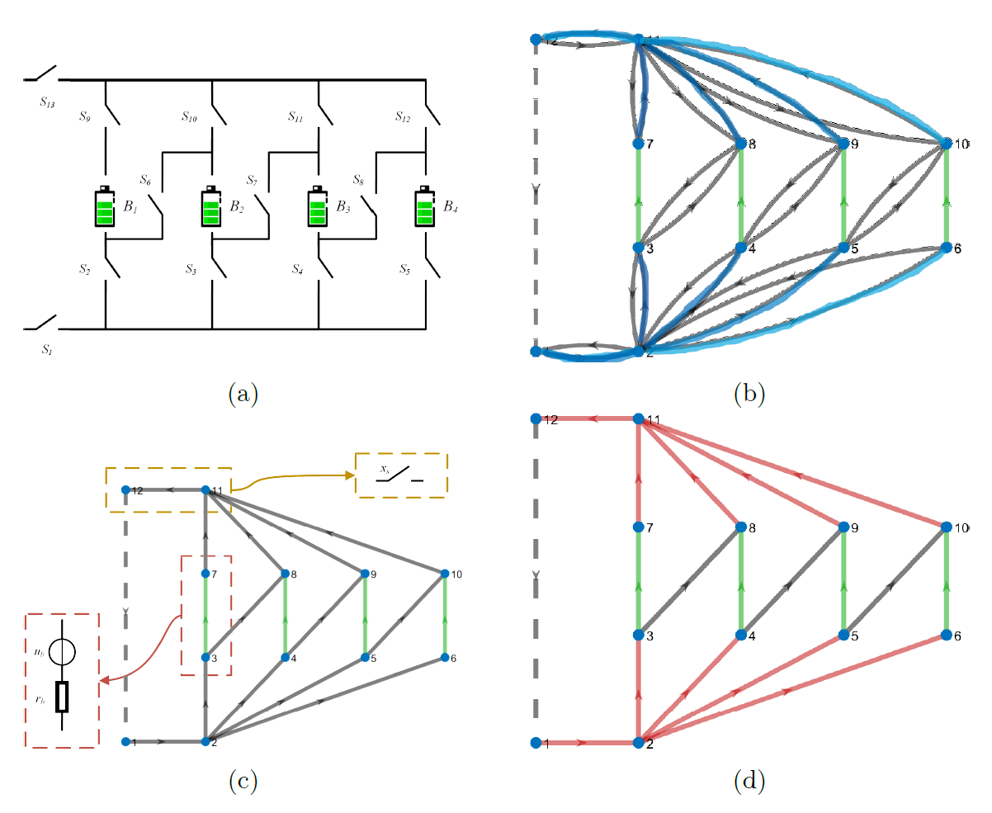

**Fig. 3 Illustration of models build in MAC calculation process. (a): physical model of RBS proposed by Visairo [8], (b): graph model of the RBS, (c): equivalent circuit model of the RBS, (d): the shortest paths find by the greedy strategy.**

The reconfigurable architecture proposed by Visairo et al. [8] is shown in Fig.3 (a). In this architecture, each cell is controlled by about 3 switches on average. Excepted for two switches ( $S_{1}$ and $S_{13}$ in Fig.3 (a)) which is used to control the total circuit, the vertical switches (e.g. $S_{2}$ and $S_{9}$) allow the batteries to be directly connected to the main circuit, and the switches in the diagonal direction ( for example) can connect the batteries in series. Thus, it can dynamically change the output voltage and current as needed. The architecture in Fig.3 (a) only has 4 batteries, but in practice it can add new branches containing batteries and switches to deal with large-scale batteries [10].

The graph in Fig.3 (b) provides the directed graph model of the RBS of Fig.3 (a), to show the connection relationship between the battery and switch in the circuit. In this model, Vertex 1 and 12 represent the anode and cathode of the RBS, respectively; the remaining vertices represent the connection nodes between the batteries and switches. Battery 1, 2, 3, and 4 are represented by green directed edges in the graph, while switches are represented by gray directed edges with opposite directions. The external electrical appliance is considered as a directed edge from node 12 to node 1. In the graph model, the directionality of the edges is strictly specified to ensure that there is no reverse flow of current in the battery and external electrical appliance.













**B. MAC calculation for RBS with different structures and sizes**

To further demonstrate the effectiveness of the models and algorithm, RBSs with different structures and sizes are considered. On the one hand, the modeling and solving of the three battery structures in Fig.1 are carried out, where the structure in Fig.1(a) is proposed by Lawson [7] and the structure in Fig.1(b) is proposed by Visairo [8]. The structure in Fig.1(c) is a combination of the two. All three structures have 4 battery cells. On the other hand, the modeling and solving of the battery structures proposed by Visairo [8] with different numbers of battery cells (2, 4, and 6 cells) are also carried out.

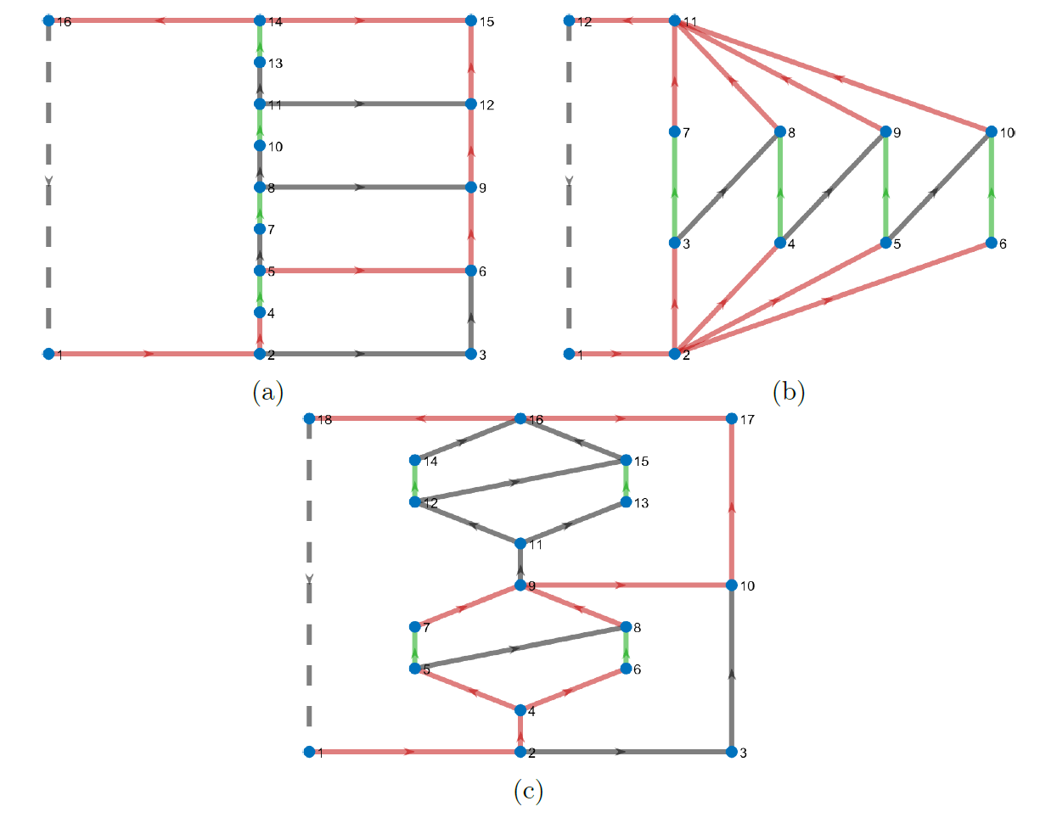

**Fig. 4 The circuit of RBS find by the developed greedy strategy which enables the MAC for RBS with structure shown in Fig. 1 respectively.**

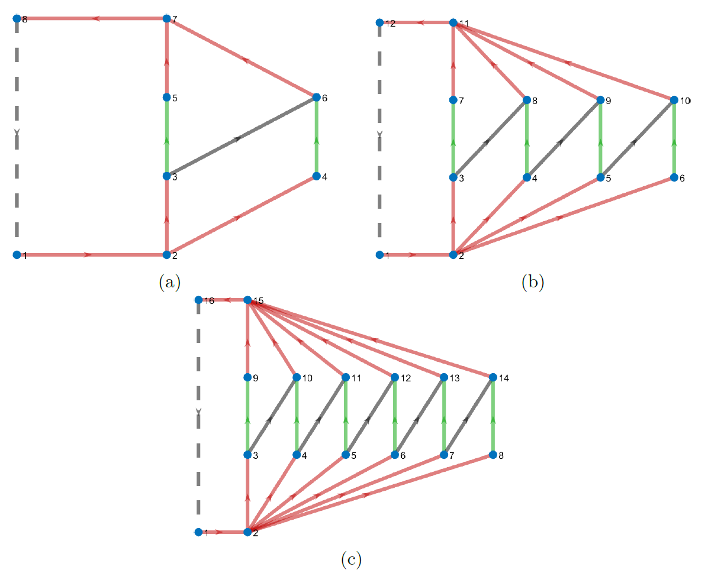

**Fig. 5 The circuit of RBS find by the developed greedy strategy which enables the MAC for RBS on structure developed by Visairo [8] with (a) 2, (b) 4 and (c) 6 batteries.**



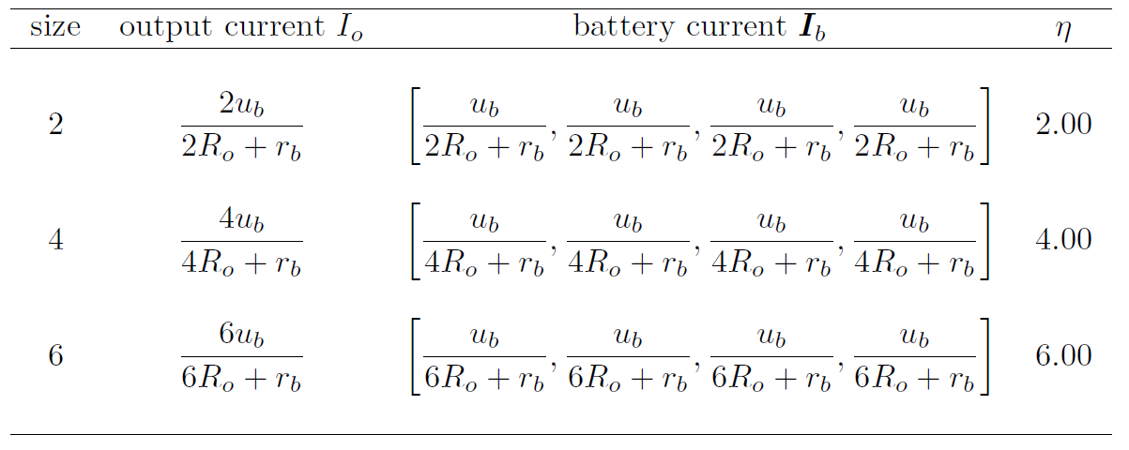

**IV. Conclusion**

This paper firstly proposes a method to calculation the MAC of RBS according to its architecture. To find the circuit in RBS that enable the MAC, a greedy strategy incorporate with the graph model is developed to. Then, the circuit model is employed to calculate the corresponding current value of the circuit found. The effectiveness of proposed method is tested on RBSs of varying structures and sizes. This work presents an effective approach to evaluate the MAC of RBS, which is essential for design and management of the RBS. Future research could focus on developing new performance indicators for evaluating RBS performance using the currents and voltages obtained by this method, as well as modifying the equivalent model of the battery to enable more accurate simulations of RBS, including transient analysis.

**Reference**

1. L. M. S. de Siqueira and W. Peng, “Control strategy to smooth wind power output using battery energy storage system: A review,” *Journal of Energy* *Storage*, vol. 35, p. 102252, Mar. 2021.
2. R. Karandeh, T. Lawanson, and V. Cecchi, “A Two-Stage Algorithm for Optimal Scheduling of Battery Energy Storage Systems for Peak-Shaving,” in *2019 North American Power Symposium (NAPS)*, pp. 1–6, Oct. 2019.
3. Y. Yang, S. Bremner, C. Menictas, and M. Kay, “Battery energy storage system size determination in renewable energy systems: A review,” *Renewable* *and Sustainable Energy Reviews*, vol. 91, pp. 109–125, Aug. 2018.
4. J. Cho, S. Jeong, and Y. Kim, “Commercial and research battery technologies for electrical energy storage applications,” *Progress in Energy and* *Combustion Science*, vol. 48, pp. 84–101, June 2015.
5. N. Yang, X. Zhang, B. Shang, and G. Li, “Unbalanced discharging and aging due to temperature differences among the cells in a lithium-ion battery pack with parallel combination,” *Journal of Power Sources*, vol. 306, pp. 733–741, Feb. 2016.
6. F. Feng, X. Hu, L. Hu, F. Hu, Y. Li, and L. Zhang, “Propagation mechanisms and diagnosis of parameter inconsistency within Li-Ion battery packs,” *Renewable and Sustainable Energy Reviews*, vol. 112, pp. 102–113, Sept. 2019.
7. B. Lawson, “A Software Configurable Battery,” *EVS26 International Battery, Hybrid and Fuel Cell Electric Vehicle Symposium*, 2012.
8. H. Visairo and P. Kumar, “A reconfigurable battery pack for improving power conversion efficiency in portable devices,” *2008 7th International* *Caribbean Conference on Devices, Circuits and Systems*, pp. 1–6, Apr. 2008.
9. W. Han, T. Wik, A. Kersten, G. Dong, and C. Zou, “Next-Generation Battery Management Systems: Dynamic Reconfiguration,” *IEEE Industrial* *Electronics Magazine*, vol. 14, pp. 20–31, Dec. 2020.
10. H. Kim and K. G. Shin, “Dependable, efficient, scalable architecture for management of large-scale batteries,” in *Proceedings of the 1st ACM/IEEE* *International Conference on Cyber-Physical Systems*, ICCPS ’10, (New York, NY, USA), pp. 178–187, Association for Computing Machinery, Apr. 2010.